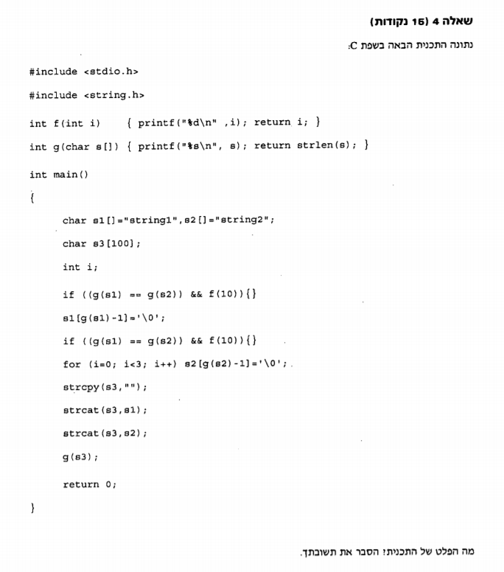

int f(int i)

{

printf("%d\n", i);//print i

return i;//return i

}

int g(char s[])

{

printf("%s\n", s);//print string

return strlen(s);//returns the length of the string

}

int main()

{

char s1[] = "string1", s2[] = "string2";

char s3[100];

int i;

if((g(s1)==g(s2))&&f(10)){}//send s1 and s2 to func g if the length is the same print 10

s1[g(s1) - 1] = '\0';//send s1 to func g and print it, then cuts the last char in s1

if((g(s1)==g(s2))&&f(10)){}//send s1 and s2 to func g if the length is the same print 10

for (i = 0; i < 3; i++) s2[g(s2) - 1] = '\0';//cuts 3 chars from s2 after printing it through func g

strcpy_s(s3, "");//copy nothing into s3

strcat_s(s3, s1);//connect s1 to the end of s3

strcat_s(s3, s2);//connect s2 to the end of s3

g(s3);//sends s3 to func g to print it

|  |  |  |  |  |  |
| --- | --- | --- | --- | --- | --- |
| F(func) | G(func) | I | S1 | S2 | S3 |
|  |  |  | String1 | String2 |  |
|  | String1 |  |  |  |  |
|  | String2 |  |  |  |  |
| 10 |  |  |  |  |  |
|  | String1 |  |  |  |  |
|  |  |  | string |  |  |
|  | String |  |  |  |  |
|  | String2 |  |  |  |  |
|  |  | 0 |  |  |  |
|  | String2 |  |  |  |  |
|  |  |  |  | string |  |
|  |  | 1 |  |  |  |
|  | string |  |  |  |  |
|  |  |  |  | strin |  |
|  |  | 2 |  |  |  |
|  | strin |  |  |  |  |
|  |  |  |  | stri |  |
|  |  | 3 |  |  |  |
|  |  |  |  |  | “” |
|  |  |  |  |  | string |
|  |  |  |  |  | stringstri |
|  | stringstri |  |  |  |  |

return 0;

}